Lab 3 Marin Aske

2.
a. Network Typology
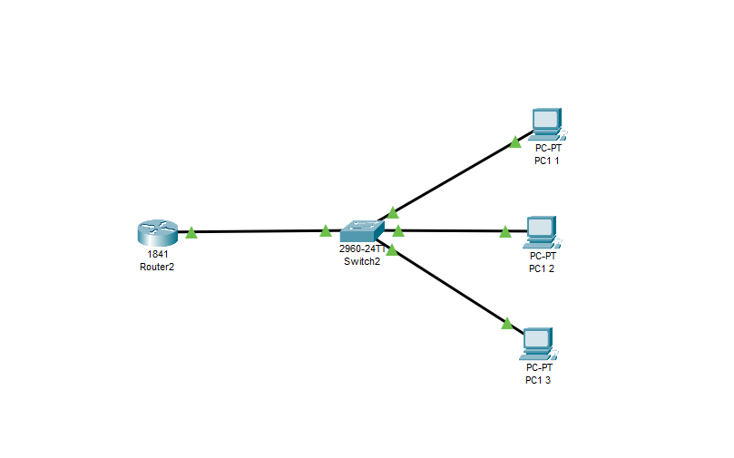

b. Ping from PC to PC (first 2) and from PC to Router (last one)
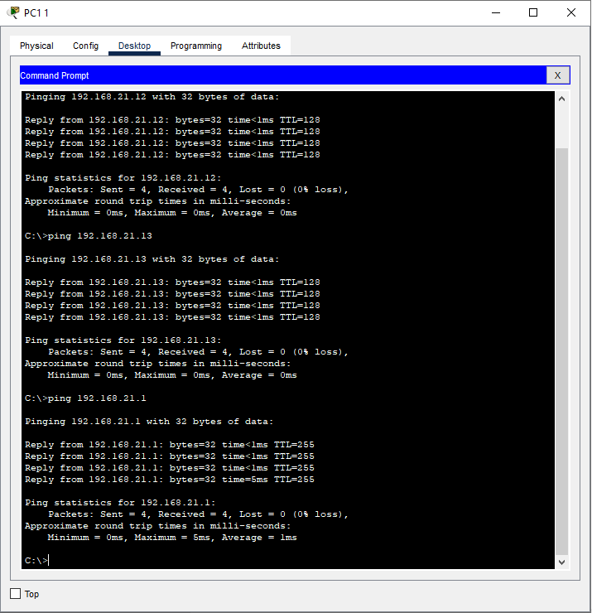

3.
a. Show Version
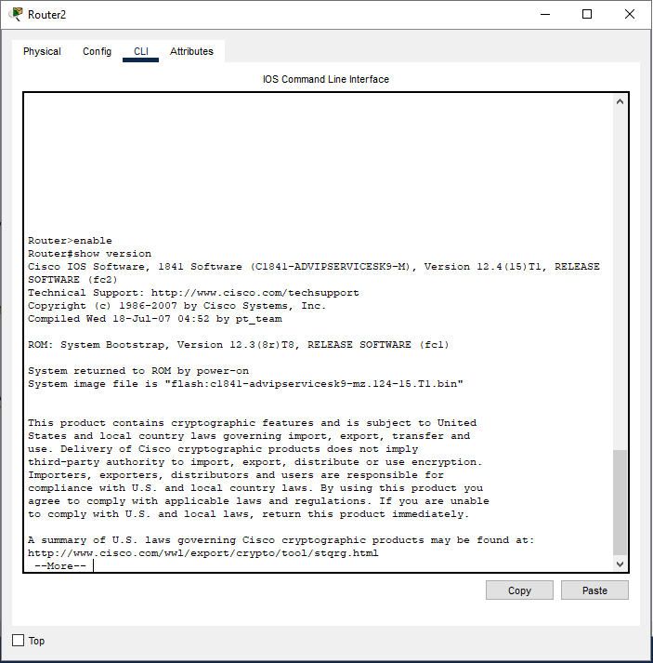

b. Show Run
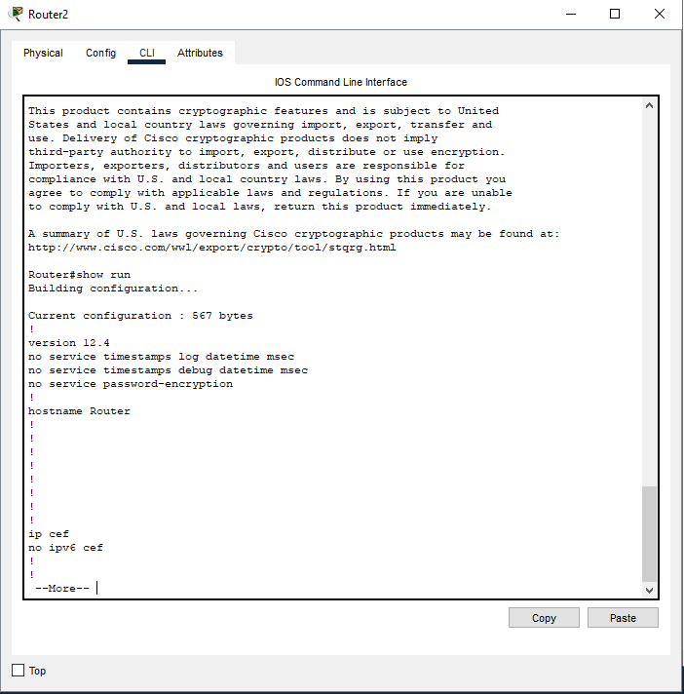

c. Show ip int brief (router and switch)
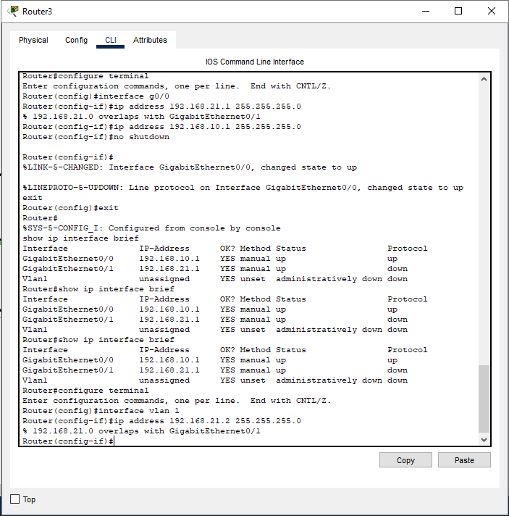
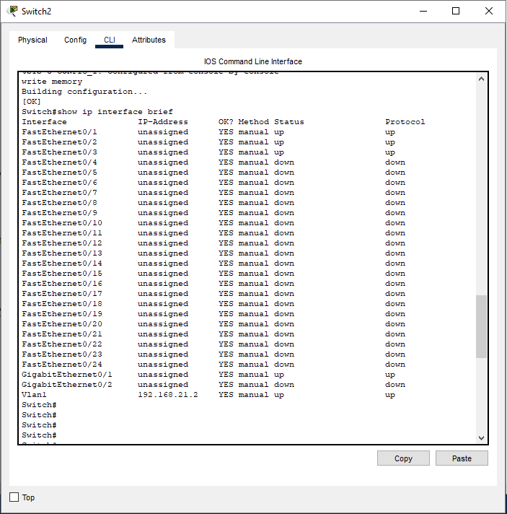

Lab 3 Questions
- What layer of the OSI model does IP addressing take place? Layer 3 - Networking

- What does DHCP stand for and how is DHCP different from static addressing? Dynamic Host Configuration Protocol. With DHCP IP addresses are configured automatically and can change while with static addressing they are set manually and never change.

- What is the command to enter privileged mode on a CISCO router or switch?

The command is “enable”.

- What command or set of commands did you use to configure the interfaces on the router and switch?
“configure terminal
Interface [interface id]
Ip address [IP-Address][subnet-mask]
No shutdown
Exit
Write memory”

- Convert the subnet mask 255.255.255.0 to binary. How many hosts can be addressed in this subnet?
255.255.255.0, when converted to binary gives us this: 11111111.11111111.11111111.00000000
For the number of usable hosts, we have 2^8 – 2 because we need to network address and the broadcast address, leaving us with 254 available hosts.

